RDV le 29 octobre à 11h

[**Carrières de Lumières**](https://www.facebook.com/CarrieresDeLumieres/?hc_ref=ARSP4ojSgQnfXm946_VtVlOi44lVMH-7BEzzFONb2tiUSN39sMiyx5Q3P-cZJHN6pYs&fref=nf&__xts__%5B0%5D=68.ARD-J6FN49k81MLcYTtXw8CTNcAdK0Hl8hLlWyttwGdyoqRdP43dfrZa1jQNt7mAx-OpWTMz1FJZVn9wBZwyJlOaiaA4Qv9VYCOKUxEtFHUkX66IG9C7YQjUptQSF370xqjAlgP09YsFzedLVjLJ0lIITt9t69U6QyYECvjOetapRub1l1ONUQjkRY7lC65iGGUBKF8UjjInVNuddH3E-d54ofY1gP50Qq1LTgFRh80V7p9-koxmizcj56WonQ5VZpRn38XzXmt2kYyesY40JfEkRL0uyIFT-t4CmDyVzBTmmfOh7Ox8MsmRdDFaruDYkHfiePPbjfs5jeBEAPIZUEmxHw&__tn__=kC-R)

[**Frise chronologique | Carrières de Lumières - Site officiel**](https://l.facebook.com/l.php?u=https%3A%2F%2Fwww.carrieres-lumieres.com%2Ffr%2Fun-peu-dhistoire%231&h=AT0qxsB_V1uHLWzJ1xFMteioj620NUeukbAGnldd41RnKt7rBBMNUwAfM_UrMbwp-ybkwf9zwXPRTZi7dL49dRCzL4by-aTbDbdb5UtCGLEfIlTWvBhAhfXTr2YYbJfEc2qeGDCedUcMSv06ZCLvQeP8d7SnYrY0R17i2Mxg_7iT6VlM7hCsyFs5y-OiyD2WmwkMKveQVOnrMxMvod5YPQIDiBmQ_SDryL8LrKYYQXIi1oacYW0lLKMKBr-zhAG0N72i_lcbtFK-SwpRv7MwYgEaCKoIGIZE_NJ8alyrUcBMcnCmhwYtjFUir6bGPzKxr015wi4OalMsbKPUjWo5kj7okfMpqO92IB1VkuTB5bXwVzJ_qDWX94nnJ1m7_hx4nuigJuz9w92-GLesgBGUsUJkmknfYpHmqAXBXcNRutthxG_PmLooi_ysj7pzazZpLFLS6cwiwDPHf1Db3404YXa7vqfqxGC387sn8ZEl6952Zha5sm2FXXLY0tRrDWqtmD_sPNIs_-Zr4YenpeYn4jcJoIzmPyepWR-Dg0SkLiGlXfSQX1NM8ychc0Lnku7RFGb0ijLupmv4-uwvTYXr_n07nTdE8H-RVdvOkrjQ2AxUFq5nABJT-BnUHHfA1FxKEe7zmFJ1a_hE_6TY2TW-6apGPg)

Carrières de Lumières - Site officiel du Château des Carrières de Lumières. visites, accueil du public,

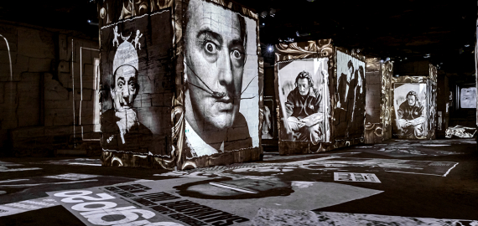  
Route de Maillane   
13520 Les Baux-de-Provence

Highlights info row image 04 90 54 47 37

Highlights info row image [www.carrieres-lumieres.com/fr](http://www.carrieres-lumieres.com/fr)

Highlights info row image [Musée (art moderne)](https://fr-fr.facebook.com/pages/category/modern-art-museum/) · [Salle de sport ou de spectacle](https://fr-fr.facebook.com/pages/category/topic-concert-venue/)